Matt Marinelli

Southern New Hampshire University

Computer Science 330

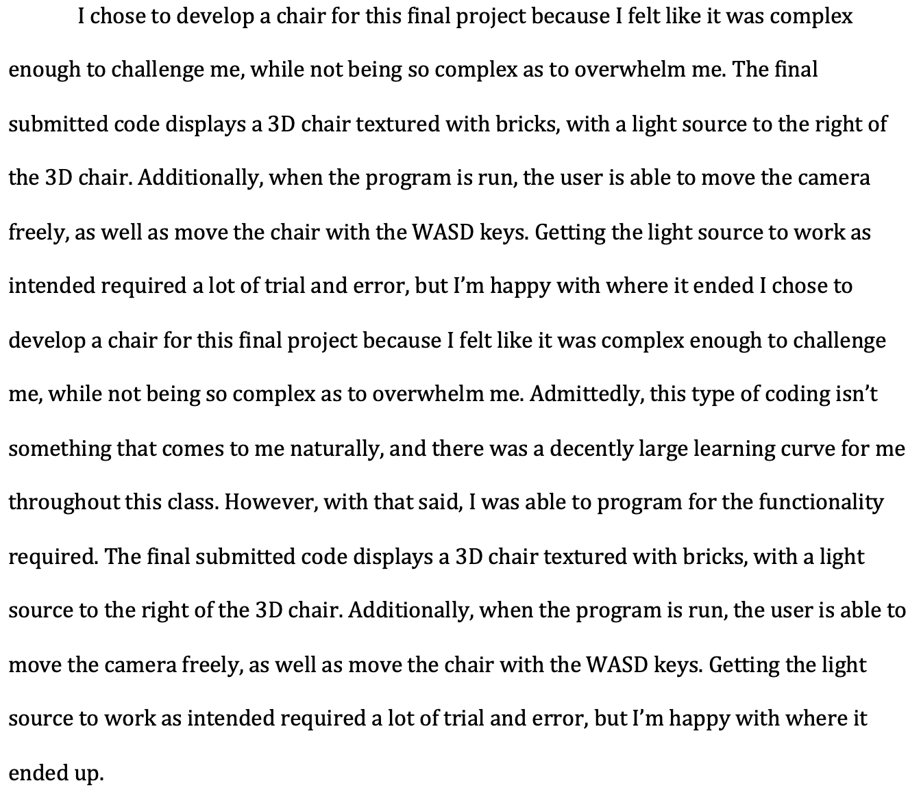

In the project, you will see a chair that is rendered in 3d. The amazing part of it is that everything is done by code. That means that the project doesn't load any 3D object. It just creates them in runtime. There is no 3D engine used so you get to see how most of the code looks that is used to make cameras, object interaction, collisions, among others. The project language is coded in C# using FREEGLUT namespace. FREEGLUT is a library that maps all OpenGL functions to .NET. In this way, you will be using OpenGL from the .NET sandbox. The project is very modular which means that every object is almost standalone. Each object actually contains all its own working logic.

The main class is main.cs . The project uses a FPS camera and you can change the camera direction with the mouse and move forward and backwards with left click/right click. You will find a chair lit up in a universe covered by a dark floor. This object was hardcoded into the GLUT library and is like the symbol of OpenGL. You will have to interact with doors. The good part is that there is no 3D engine behind it so you get to see how it is actually done. If you look into the code, you will realize how my object is built by combining simple OpenGL primitives. If you rotate my object, you will see the sky and the ground. For this project, I learned the basics for rendering the environment in 3D programming. This could be classified as a textured cube and a plane for the ground. 